Agentic AI Content Creator
Project Overview:
Agentic AI Content Creator is a project developed using Python, Streamlit, and Google Gemini AI.
The application helps content creators generate complete social media content automatically by taking user inputs such as Topic, Audience, Goal, Platform, and Content Type.
The system uses AI to generate:
• Content Strategy
• Content Ideas
• Social Media Hooks
• Captions
• Hashtags
• Best Posting Time
This helps content creators save time and improve their content planning process.

Objective:
The objective of this project is to automate social media content creation using Artificial Intelligence.
Instead of manually planning content, users can enter a few details and receive a complete content package instantly.

Technologies Used
Programming Language:
- Python
Framework:
- Streamlit
AI Model:
- Google Gemini 2.5 Flash
Libraries:
- google-generativeai
- streamlit
- python-dotenv
Development Environment:
- Visual Studio Code

Project Architecture

+------------------+
| User |
+------------------+
|
v
+------------------+
| Streamlit UI |
+------------------+
|
v
+------------------+
| Planner Agent |
+------------------+
|
v
+------------------+
| Idea Agent |
+------------------+
|
v
+------------------+
| Hook Agent |
+------------------+
|
v
+------------------+
| Caption Agent |
+------------------+
|
v
+------------------+
| Hashtag Agent |
+------------------+
|
v
+------------------+
| Posting Time |
| Agent |
+------------------+
|
v
+------------------+
| Final Content |
+------------------+

Implementation Steps
Step 1:
Installed Python and Visual Studio Code.
Step 2:
Created a project folder named: “ContentCreatorAgent”
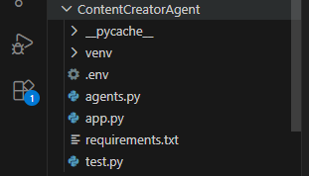
Step 3:
Created and activated a Python virtual environment.
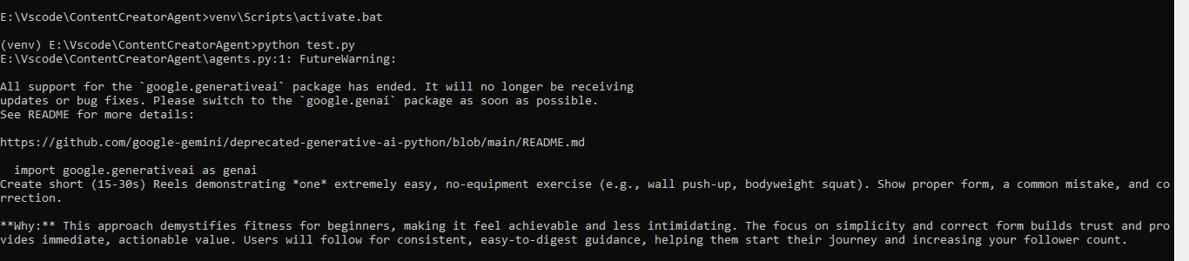
Step 4:
Installed required dependencies:
Commands -
pip install google-generativeai
pip install python-dotenv
pip install streamlit

Step 5:
Created a .env file and stored the Gemini API Key which was created from the Gemini
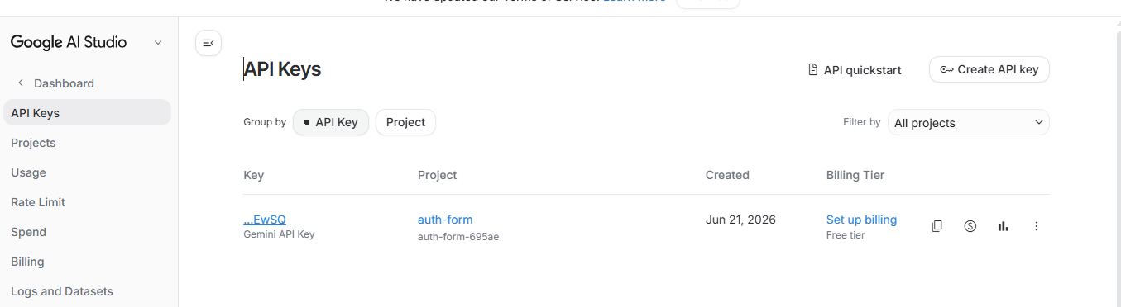
Step 6:
Created agents.py file containing the AI content generation logic.
Agents Python code-
import google.generativeai as genai
import os
from dotenv import load_dotenv

load_dotenv()

genai.configure(
api_key=os.getenv("GEMINI_API_KEY")
)

model = genai.GenerativeModel(
"gemini-2.5-flash"
)

def content_creator_agent(
topic,
audience,
goal,
platform,
content_type
):

prompt = f"""
You are an expert AI Content Creator.
Topic: {topic}
Audience: {audience}
Goal: {goal}
Platform: {platform}
Content Type: {content_type}

Generate:
1. Content Strategy
2. Content Idea
3. Hook
4. Caption
5. 10 Relevant Hashtags
6. Best Posting Time

Format the output clearly with headings.
"""
response = model.generate_content(prompt)
return response.text

Step 7:
Created app.py file using Streamlit for the user interface.
APP Python File
import streamlit as st

from agents import content_creator_agent

st.set_page_config(
page_title="Agentic AI Content Creator",
page_icon="🤖",
layout="wide"
)

st.title("🤖 Agentic AI Content Creator")

st.markdown(
"""
Generate complete social media content using AI.

```
### Features
✅ Content Strategy
✅ Content Idea
✅ Hook Generator
✅ Caption Generator
✅ Hashtag Generator
✅ Best Posting Time
"""

)

topic = st.text_input("Topic")

audience = st.text_input("Target Audience")

goal = st.selectbox(
"Goal",
[
"Increase Followers",
"Increase Engagement",
"Brand Awareness"
]
)

platform = st.selectbox(
"Platform",
[
"Instagram",
"LinkedIn",
"YouTube"
]
)

content_type = st.selectbox(
"Content Type",
[
"Reel",
"Post",
"Carousel"
]
)

if st.button("Generate Content"):
with st.spinner("Generating Content..."):
result = content_creator_agent(
topic,
audience,
goal,
platform,
content_type
)

st.success(
"Content Generated Successfully!"
)

st.markdown(result)

Command - streamlit run app.py
UI:
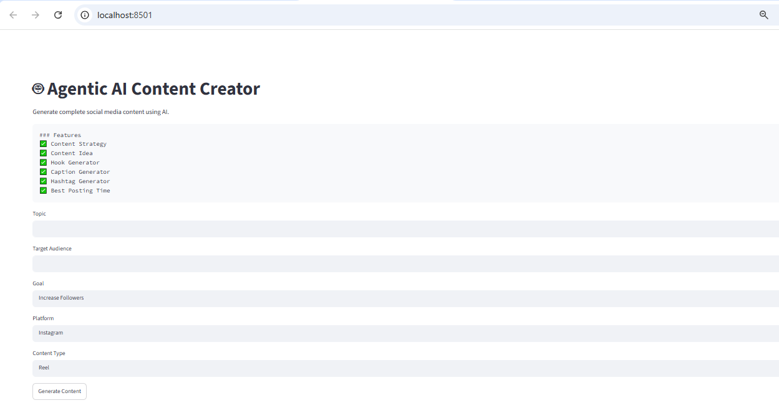
Step 8:
Integrated Gemini AI API for content generation.
Step 10:
Generated content successfully through the Streamlit interface.
Test Python File
test.py
↓
Checks whether all agents are working correctly

Why we created test.py
Before building the UI, we wanted to verify:
✅ Gemini API is working
✅ API Key is loaded correctly
✅ Planner Agent is generating strategy
✅ Idea Agent is generating ideas
✅ Hook Agent is generating hooks
✅ Caption Agent is generating captions
✅ Hashtag Agent is generating hashtags
✅ Posting Time Agent is generating recommendations
from agents import (
planner_agent,
idea_agent,
hook_agent,
caption_agent,
hashtag_agent,
posting_time_agent
)

# Planner Agent

strategy = planner_agent(
topic="Fitness",
audience="Beginners",
goal="Increase Followers",
platform="Instagram",
content_type="Reel"
)

# Idea Agent

idea = idea_agent(
topic="Fitness",
audience="Beginners",
content_type="Reel"
)

# Hook Agent

hook = hook_agent(idea)

# Caption Agent

caption = caption_agent(idea, hook)

# Hashtag Agent

hashtags = hashtag_agent("Fitness")

# Posting Time Agent

posting_time = posting_time_agent("Instagram")

print("\n========================")
print("CONTENT STRATEGY")
print("========================\n")
print(strategy)

print("\n========================")
print("CONTENT IDEA")
print("========================\n")
print(idea)

print("\n========================")
print("HOOK")
print("========================\n")
print(hook)

print("\n========================")
print("CAPTION")
print("========================\n")
print(caption)

print("\n========================")
print("HASHTAGS")
print("========================\n")
print(hashtags)

print("\n========================")
print("BEST POSTING TIME")
print("========================\n")
print(posting_time)

Agents Handshake
1. Planner Agent
The Planner Agent is responsible for creating the overall content strategy. It analyzes the topic, target audience, platform, goal, and content type provided by the user. Based on these inputs, it suggests the most effective content approach to achieve the desired objective, such as increasing followers, engagement, or brand awareness.
Output: Content Strategy

2. Idea Agent
The Idea Agent generates creative and engaging content ideas based on the selected topic and audience. Its purpose is to help content creators discover interesting content concepts that attract attention and provide value to their audience.
Output: Content Idea

3. Hook Agent
The Hook Agent creates attention-grabbing opening lines or hooks. The hook is designed to capture the audience's interest within the first few seconds of viewing the content, increasing the chances of engagement and retention.
Output: Social Media Hook

4. Caption Agent
The Caption Agent generates a complete social media caption based on the content idea and hook. It creates engaging and informative text that encourages users to interact with the content through likes, comments, shares, or follows.
Output: Social Media Caption

5. Hashtag Agent
The Hashtag Agent generates relevant and trending hashtags related to the content topic. These hashtags help improve content visibility, discoverability, and audience reach on social media platforms.
Output: List of Relevant Hashtags

6. Posting Time Agent
The Posting Time Agent recommends the optimal time to publish content on the selected platform. It provides a suggested posting schedule along with a reason, helping creators maximize audience engagement and content performance.
Input: Platform
Output: Best Posting Time Recommendation

Command– python test.py
Output:


